LAPORAN PENGERJAAN UJI KOMPETENSI KEJURUAN SMK MAHARDHIKA BATUJAJAR

TAHUN PELAJARAN 2022-2023

KOMPETENSI KEAHLIAN : Rekayasa Perangkat Lunak KELAS : XII RPL 2

NAMA LENGKAP : Jizdan Ridwan Zhafir

NIS :

PAKET SOAL : P2

JENIS APLIKASI : Web

ALOKASI WAKTU : 24 jam

# PENJADWALAN KEGIATAN



# PERSIAPAN PERANGKAT KERAS

A. Monitor

B. Keyboard

# PERSIAPAN PERANGKAT LUNAK

A. Os Windows 7 ultimate 64-bit

B. Xampp

C. Visual studio code

D. Astah

E. Excel

F. Word

G. Google Chrome

# H. Balsamiq

# I. SQL

# 4.PERANCANGAN ALGORITMA APLIKASI

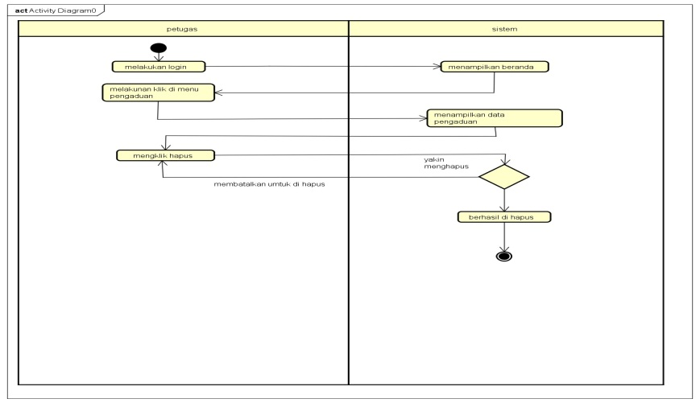

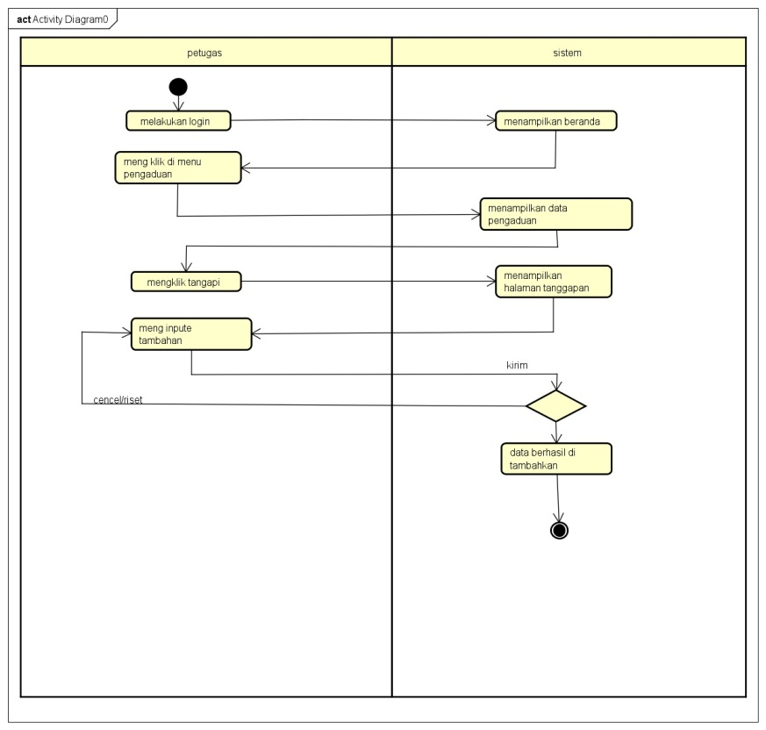

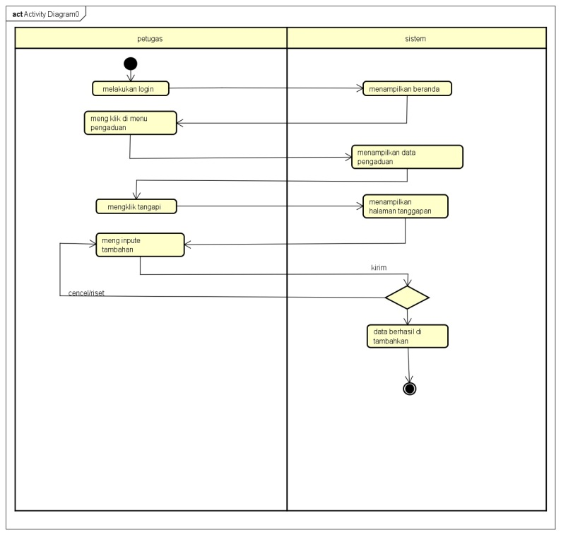

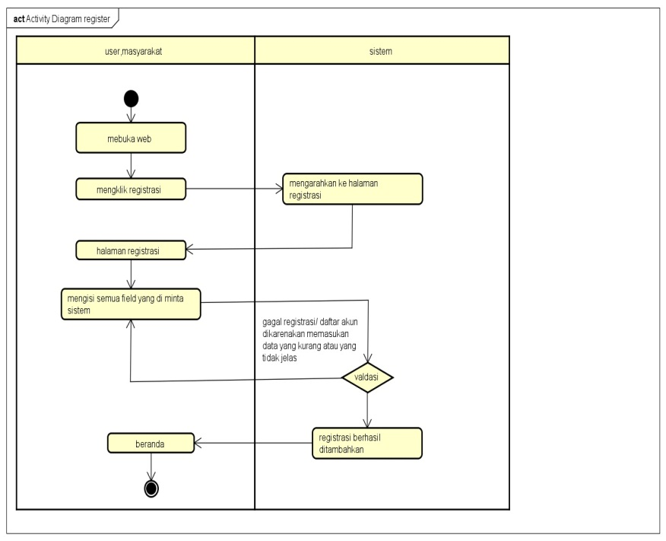

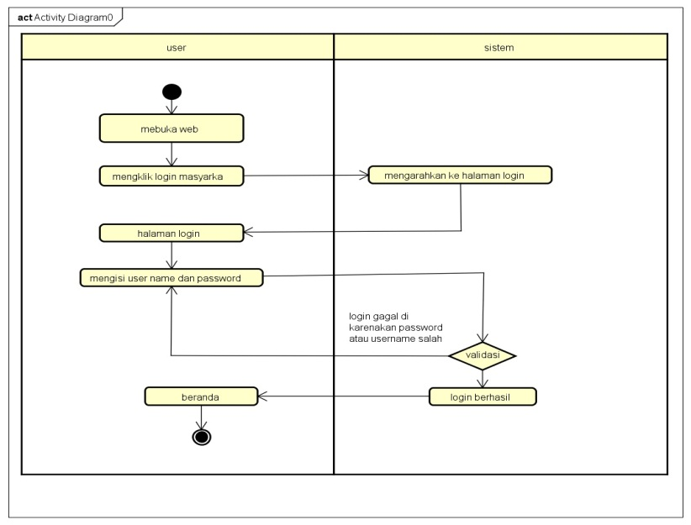

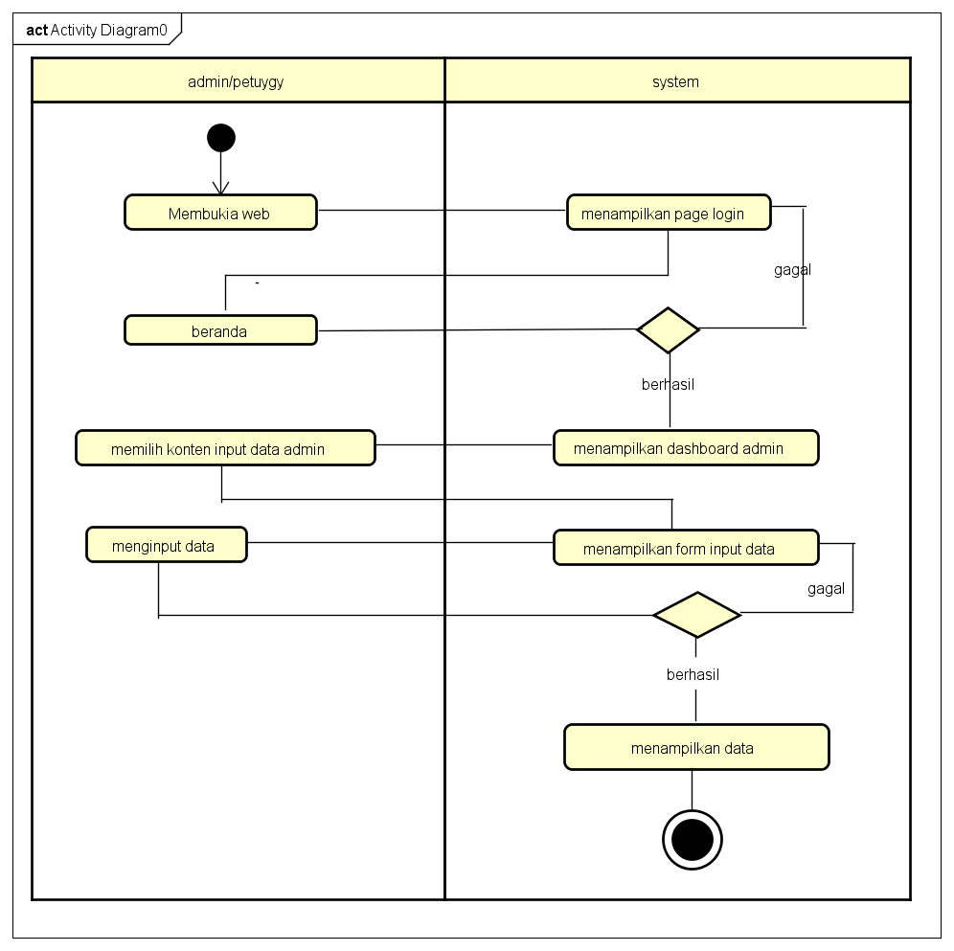

# 5. PERANCANGAN DESAIN BASIS DATA

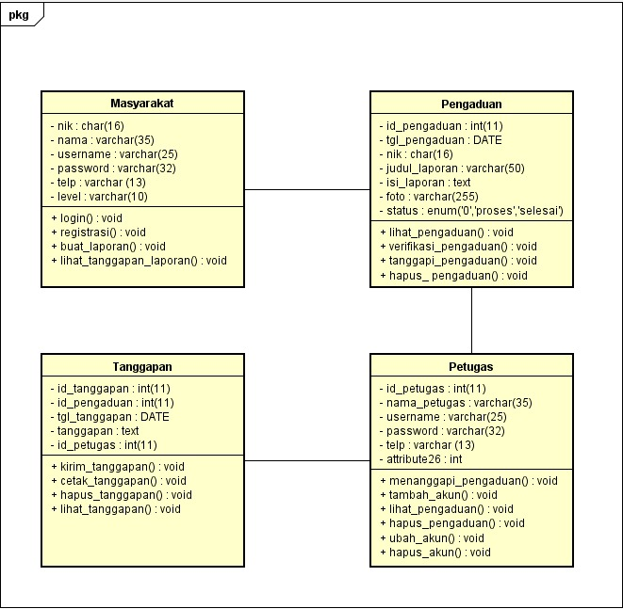

# 6.DUMMY DATA

# 1.Data Masyarakat

|  |  |  |  |  |  |
| --- | --- | --- | --- | --- | --- |
| Nik | Nama | Username | Password | Telepon | Level |
| -1 | jizdan ridwan | jizdanrz | af616f41c52c0e1addf8b862b07f1f7f | 0895360457269 | masyarakat |
| 1234 | jizdan | jizdan | af616f41c52c0e1addf8b862b07f1f7f | 0888962734544 | masyarakat |
| 5421345 | april | april | |  |  | | --- | --- | |  |  |  d93591bdf7860e1e4ee2fca799911215 | 75314677 | masyarakat |

# 2. Data Petugas

|  |  |  |  |  |  |
| --- | --- | --- | --- | --- | --- |
| **Id_petugas** | **Nama_petugas** | **Username** | **Password** | **Telepon** | **Level** |
| **1** | **petugas** | **petugas** | afb91ef692fd08c445e8cb1bab2ccf9c | 081345235425 | **petugas** |
| **4** | **admin** | **admin** | 21232f297a57a5a743894a0e4a801fc3 | 08523321312 | **admin** |

# 7. PEMBUATAN BASIS DATA (MySQL Code)

# 1. Pengaduan

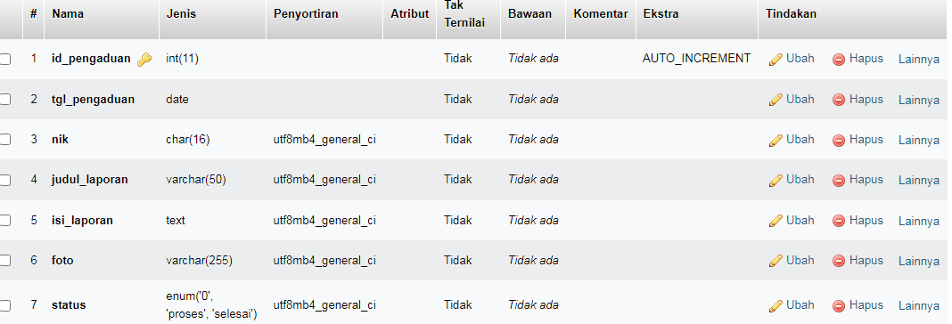

2. Petugas

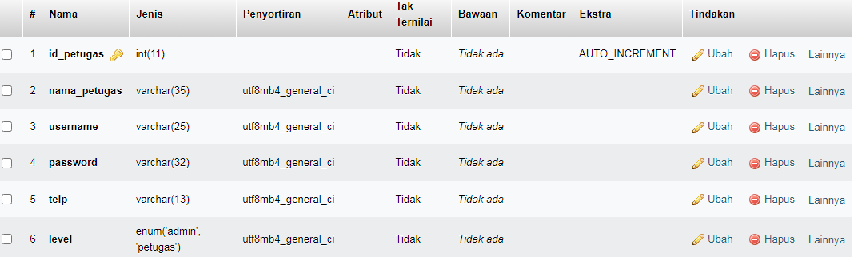

3. Tanggapan

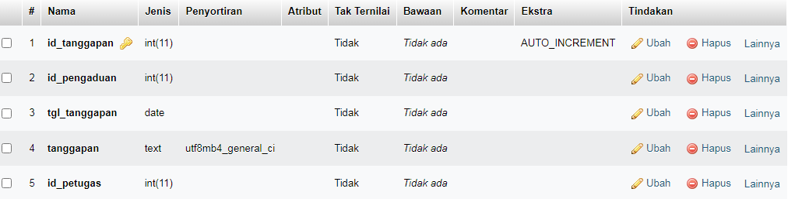

4. Masyarakat

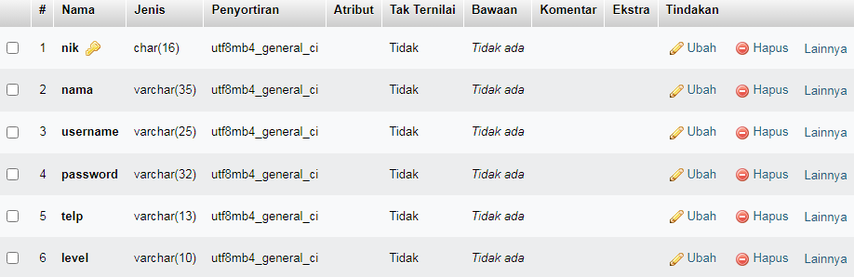

# 8. PERANCANGAN TAMPILAN ANTARMUKA (UI) WEB

* + **Aplikasi pengaduan masyarakat**

1. *Silahkan gambarkan use case diagram aplikasi yang kamu buat*
2. Admin dashboard

Tampilan untuk full manage semua data, buatkan sketsa/mockup-nya

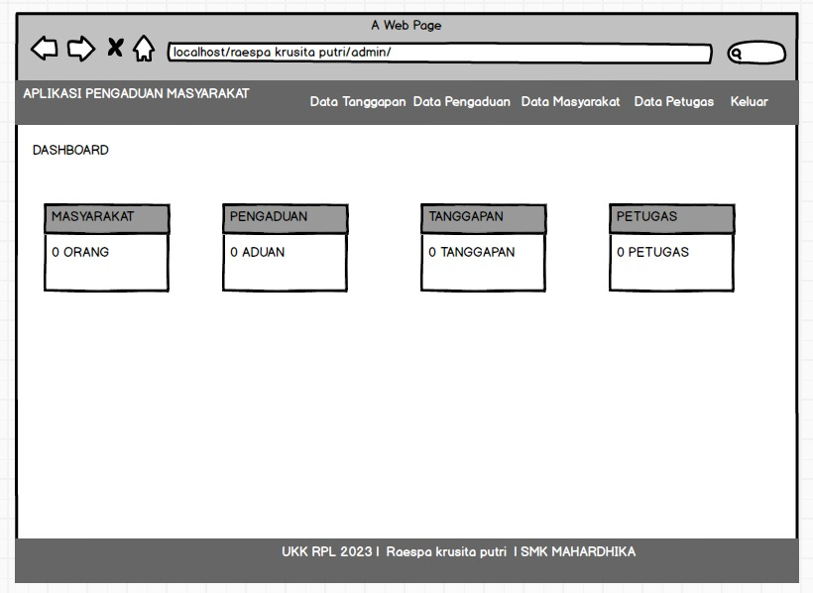

1. Tampilan Petugas buatkan sketsa/mockup-nya

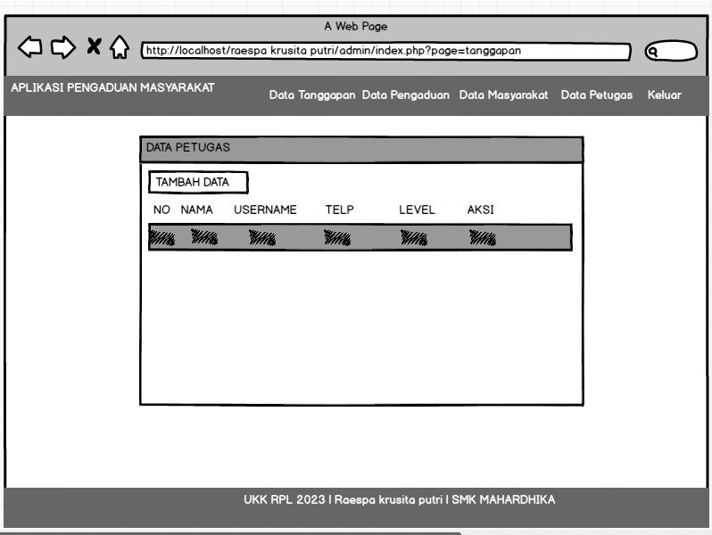

1. Tampilan masyarakat

Dashboard,about,tambah laporan,daftar komentar, tanggapan, buatkan sketsa/mockup-nya

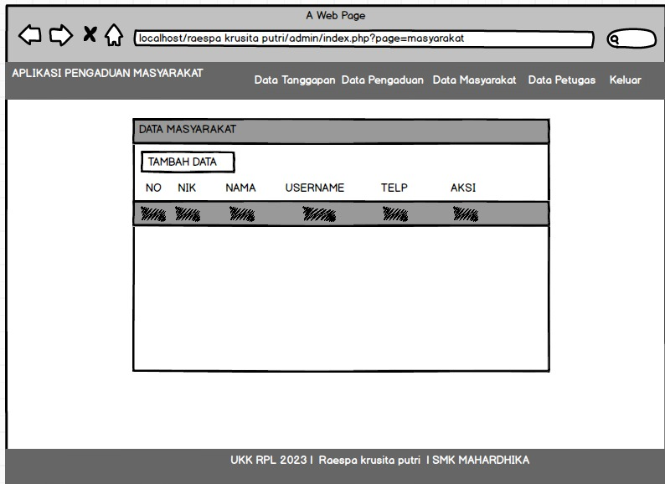

# Aplikasi pengelolaan laundry

1. *Silahkan gambarkan use case diagram aplikasi yang kamu buat*
2. Admin dashboard

Tampilan untuk full manage semua data, buatkan sketsa/mockup-nya

1. Tampilan Kasir

Setiap menu buatkan sketsa/mockup-nya

1. Tampilan owner

Setiap menu buatkan sketsa/mockup-nya

# 9. PEMBUATAN STRUKTUR WEB (HTML)

|  |
| --- |
| <!DOCTYPE html>  <html>  <head>    <meta charset="utf-8">    <meta name="viewport" content="width=device-width, initial-scaled=1">    <title>Aplikasi Pengaduan Masyarakat | Jizdan</title>    <link rel="stylesheet" type="text/css" href="assets/css/bootstrap.min.css">  </head>  <body>    <nav class="navbar navbar-expand-lg" style="background-color: lightblue;">    <div class="container">      <a class="navbar-brand" href="index.php">Aplikasi Pengaduan Masyarakat</a>      <button class="navbar-toggler" type="button" data-bs-toggle="collapse" data-bs-target="#navbarNav" aria-controls="navbarNav" aria-expanded="false" aria-label="Toggle navigation">        <span class="navbar-toggler-icon"></span>      </button>      <div class="collapse navbar-collapse justify-content-end" id="navbarNav">        <ul class="navbar-nav">          <li class="nav-item">            <a class="nav-link" href="index.php?page=registrasi">Daftar Akun</a>          </li>          <li class="nav-item">            <a class="nav-link" href="index.php?page=login">Login</a>          </li>        </ul>      </div>    </div>  </nav>  <?php  if (isset($_GET['page'])) {    $page= $_GET['page'];    switch ($page) {      case 'login':        include 'login.php';        break;        case 'registrasi':          include 'registrasi.php';          break;        default:        echo "Halaman tidak tersedia";        break;    }  } else {    include 'home.php';  }   ?>  <footer class="fixed-button" style="background-color: light ">    <div class="container">      <p class="text-center">UKK RPL 2023 | Jizdan | SMK MAHARDIKA</p>    </div>  </footer>  <script type="text/javascript" src="assets/js/bootstrap.min.js"></script>  </body>  </html> |

10. PEMBUATAN STYLE WEB (CSS) File style.css

|  |
| --- |
| /*!   * Bootstrap Reboot v5.3.0-alpha1 (https://getbootstrap.com/)   * Copyright 2011-2022 The Bootstrap Authors   * Licensed under MIT (https://github.com/twbs/bootstrap/blob/main/LICENSE)   */:root,[data-bs-theme=light]{--bs-blue:#0d6efd;--bs-indigo:#6610f2;--bs-purple:#6f42c1;--bs-pink:#d63384;--bs-red:#dc3545;--bs-orange:#fd7e14;--bs-yellow:#ffc107;--bs-green:#198754;--bs-teal:#20c997;--bs-cyan:#0dcaf0;--bs-black:#000;--bs-white:#fff;--bs-gray:#6c757d;--bs-gray-dark:#343a40;--bs-gray-100:#f8f9fa;--bs-gray-200:#e9ecef;--bs-gray-300:#dee2e6;--bs-gray-400:#ced4da;--bs-gray-500:#adb5bd;--bs-gray-600:#6c757d;--bs-gray-700:#495057;--bs-gray-800:#343a40;--bs-gray-900:#212529;--bs-primary:#0d6efd;--bs-secondary:#6c757d;--bs-success:#198754;--bs-info:#0dcaf0;--bs-warning:#ffc107;--bs-danger:#dc3545;--bs-light:#f8f9fa;--bs-dark:#212529;--bs-primary-rgb:13,110,253;--bs-secondary-rgb:108,117,125;--bs-success-rgb:25,135,84;--bs-info-rgb:13,202,240;--bs-warning-rgb:255,193,7;--bs-danger-rgb:220,53,69;--bs-light-rgb:248,249,250;--bs-dark-rgb:33,37,41;--bs-primary-text:#0a58ca;--bs-secondary-text:#6c757d;--bs-success-text:#146c43;--bs-info-text:#087990;--bs-warning-text:#997404;--bs-danger-text:#b02a37;--bs-light-text:#6c757d;--bs-dark-text:#495057;--bs-primary-bg-subtle:#cfe2ff;--bs-secondary-bg-subtle:#f8f9fa;--bs-success-bg-subtle:#d1e7dd;--bs-info-bg-subtle:#cff4fc;--bs-warning-bg-subtle:#fff3cd;--bs-danger-bg-subtle:#f8d7da;--bs-light-bg-subtle:#fcfcfd;--bs-dark-bg-subtle:#ced4da;--bs-primary-border-subtle:#9ec5fe;--bs-secondary-border-subtle:#e9ecef;--bs-success-border-subtle:#a3cfbb;--bs-info-border-subtle:#9eeaf9;--bs-warning-border-subtle:#ffe69c;--bs-danger-border-subtle:#f1aeb5;--bs-light-border-subtle:#e9ecef;--bs-dark-border-subtle:#adb5bd;--bs-white-rgb:255,255,255;--bs-black-rgb:0,0,0;--bs-body-color-rgb:33,37,41;--bs-body-bg-rgb:255,255,255;--bs-font-sans-serif:system-ui,-apple-system,"Segoe UI",Roboto,"Helvetica Neue","Noto Sans","Liberation Sans",Arial,sans-serif,"Apple Color Emoji","Segoe UI Emoji","Segoe UI Symbol","Noto Color Emoji";--bs-font-monospace:SFMono-Regular,Menlo,Monaco,Consolas,"Liberation Mono","Courier New",monospace;--bs-gradient:linear-gradient(180deg, rgba(255, 255, 255, 0.15), rgba(255, 255, 255, 0));--bs-body-font-family:var(--bs-font-sans-serif);--bs-body-font-size:1rem;--bs-body-font-weight:400;--bs-body-line-height:1.5;--bs-body-color:#212529;--bs-emphasis-color:#000;--bs-emphasis-color-rgb:0,0,0;--bs-secondary-color:rgba(33, 37, 41, 0.75);--bs-secondary-color-rgb:33,37,41;--bs-secondary-bg:#e9ecef;--bs-secondary-bg-rgb:233,236,239;--bs-tertiary-color:rgba(33, 37, 41, 0.5);--bs-tertiary-color-rgb:33,37,41;--bs-tertiary-bg:#f8f9fa;--bs-tertiary-bg-rgb:248,249,250;--bs-body-bg:#fff;--bs-body-bg-rgb:255,255,255;--bs-link-color:#0d6efd;--bs-link-color-rgb:13,110,253;--bs-link-decoration:underline;--bs-link-hover-color:#0a58ca;--bs-link-hover-color-rgb:10,88,202;--bs-code-color:#d63384;--bs-highlight-bg:#fff3cd;--bs-border-width:1px;--bs-border-style:solid;--bs-border-color:#dee2e6;--bs-border-color-translucent:rgba(0, 0, 0, 0.175);--bs-border-radius:0.375rem;--bs-border-radius-sm:0.25rem;--bs-border-radius-lg:0.5rem;--bs-border-radius-xl:1rem;--bs-border-radius-2xl:2rem;--bs-border-radius-pill:50rem;--bs-box-shadow:0 0.5rem 1rem rgba(var(--bs-body-color-rgb), 0.15);--bs-box-shadow-sm:0 0.125rem 0.25rem rgba(var(--bs-body-color-rgb), 0.075);--bs-box-shadow-lg:0 1rem 3rem rgba(var(--bs-body-color-rgb), 0.175);--bs-box-shadow-inset:inset 0 1px 2px rgba(var(--bs-body-color-rgb), 0.075);--bs-emphasis-color:#000;--bs-form-control-bg:var(--bs-body-bg);--bs-form-control-disabled-bg:var(--bs-secondary-bg);--bs-highlight-bg:#fff3cd;--bs-breakpoint-xs:0;--bs-breakpoint-sm:576px;--bs-breakpoint-md:768px;--bs-breakpoint-lg:992px;--bs-breakpoint-xl:1200px;--bs-breakpoint-xxl:1400px}[data-bs-theme=dark]{--bs-body-color:#adb5bd;--bs-body-color-rgb:173,181,189;--bs-body-bg:#212529;--bs-body-bg-rgb:33,37,41;--bs-emphasis-color:#f8f9fa;--bs-emphasis-color-rgb:248,249,250;--bs-secondary-color:rgba(173, 181, 189, 0.75);--bs-secondary-color-rgb:173,181,189;--bs-secondary-bg:#343a40;--bs-secondary-bg-rgb:52,58,64;--bs-tertiary-color:rgba(173, 181, 189, 0.5);--bs-tertiary-color-rgb:173,181,189;--bs-tertiary-bg:#2b3035;--bs-tertiary-bg-rgb:43,48,53;--bs-emphasis-color:#fff;--bs-primary-text:#6ea8fe;--bs-secondary-text:#dee2e6;--bs-success-text:#75b798;--bs-info-text:#6edff6;--bs-warning-text:#ffda6a;--bs-danger-text:#ea868f;--bs-light-text:#f8f9fa;--bs-dark-text:#dee2e6;--bs-primary-bg-subtle:#031633;--bs-secondary-bg-subtle:#212529;--bs-success-bg-subtle:#051b11;--bs-info-bg-subtle:#032830;--bs-warning-bg-subtle:#332701;--bs-danger-bg-subtle:#2c0b0e;--bs-light-bg-subtle:#343a40;--bs-dark-bg-subtle:#1a1d20;--bs-primary-border-subtle:#084298;--bs-secondary-border-subtle:#495057;--bs-success-border-subtle:#0f5132;--bs-info-border-subtle:#055160;--bs-warning-border-subtle:#664d03;--bs-danger-border-subtle:#842029;--bs-light-border-subtle:#495057;--bs-dark-border-subtle:#343a40;--bs-heading-color:#fff;--bs-link-color:#6ea8fe;--bs-link-hover-color:#9ec5fe;--bs-link-color-rgb:110,168,254;--bs-link-hover-color-rgb:158,197,254;--bs-code-color:#e685b5;--bs-border-color:#495057;--bs-border-color-translucent:rgba(255, 255, 255, 0.15)}*,::after,::before{box-sizing:border-box}@media (prefers-reduced-motion:no-preference){:root{scroll-behavior:smooth}}body{margin:0;font-family:var(--bs-body-font-family);font-size:var(--bs-body-font-size);font-weight:var(--bs-body-font-weight);line-height:var(--bs-body-line-height);color:var(--bs-body-color);text-align:var(--bs-body-text-align);background-color:var(--bs-body-bg);-webkit-text-size-adjust:100%;-webkit-tap-highlight-color:transparent}hr{margin:1rem 0;color:inherit;border:0;border-top:var(--bs-border-width) solid;opacity:.25}h1,h2,h3,h4,h5,h6{margin-top:0;margin-bottom:.5rem;font-weight:500;line-height:1.2;color:var(--bs-heading-color,inherit)}h1{font-size:calc(1.375rem + 1.5vw)}@media (min-width:1200px){h1{font-size:2.5rem}}h2{font-size:calc(1.325rem + .9vw)}@media (min-width:1200px){h2{font-size:2rem}}h3{font-size:calc(1.3rem + .6vw)}@media (min-width:1200px){h3{font-size:1.75rem}}h4{font-size:calc(1.275rem + .3vw)}@media (min-width:1200px){h4{font-size:1.5rem}}h5{font-size:1.25rem}h6{font-size:1rem}p{margin-top:0;margin-bottom:1rem}abbr[title]{-webkit-text-decoration:underline dotted;text-decoration:underline dotted;cursor:help;-webkit-text-decoration-skip-ink:none;text-decoration-skip-ink:none}address{margin-bottom:1rem;font-style:normal;line-height:inherit}ol,ul{padding-left:2rem}dl,ol,ul{margin-top:0;margin-bottom:1rem}ol ol,ol ul,ul ol,ul ul{margin-bottom:0}dt{font-weight:700}dd{margin-bottom:.5rem;margin-left:0}blockquote{margin:0 0 1rem}b,strong{font-weight:bolder}small{font-size:.875em}mark{padding:.1875em;background-color:var(--bs-highlight-bg)}sub,sup{position:relative;font-size:.75em;line-height:0;vertical-align:baseline}sub{bottom:-.25em}sup{top:-.5em}a{color:rgba(var(--bs-link-color-rgb),var(--bs-link-opacity,1));text-decoration:underline}a:hover{--bs-link-color-rgb:var(--bs-link-hover-color-rgb)}a:not([href]):not([class]),a:not([href]):not([class]):hover{color:inherit;text-decoration:none}code,kbd,pre,samp{font-family:var(--bs-font-monospace);font-size:1em}pre{display:block;margin-top:0;margin-bottom:1rem;overflow:auto;font-size:.875em}pre code{font-size:inherit;color:inherit;word-break:normal}code{font-size:.875em;color:var(--bs-code-color);word-wrap:break-word}a>code{color:inherit}kbd{padding:.1875rem .375rem;font-size:.875em;color:var(--bs-body-bg);background-color:var(--bs-body-color);border-radius:.25rem}kbd kbd{padding:0;font-size:1em}figure{margin:0 0 1rem}img,svg{vertical-align:middle}table{caption-side:bottom;border-collapse:collapse}caption{padding-top:.5rem;padding-bottom:.5rem;color:var(--bs-secondary-color);text-align:left}th{text-align:inherit;text-align:-webkit-match-parent}tbody,td,tfoot,th,thead,tr{border-color:inherit;border-style:solid;border-width:0}label{display:inline-block}button{border-radius:0}button:focus:not(:focus-visible){outline:0}button,input,optgroup,select,textarea{margin:0;font-family:inherit;font-size:inherit;line-height:inherit}button,select{text-transform:none}[role=button]{cursor:pointer}select{word-wrap:normal}select:disabled{opacity:1}[list]:not([type=date]):not([type=datetime-local]):not([type=month]):not([type=week]):not([type=time])::-webkit-calendar-picker-indicator{display:none!important}[type=button],[type=reset],[type=submit],button{-webkit-appearance:button}[type=button]:not(:disabled),[type=reset]:not(:disabled),[type=submit]:not(:disabled),button:not(:disabled){cursor:pointer}::-moz-focus-inner{padding:0;border-style:none}textarea{resize:vertical}fieldset{min-width:0;padding:0;margin:0;border:0}legend{float:left;width:100%;padding:0;margin-bottom:.5rem;font-size:calc(1.275rem + .3vw);line-height:inherit}@media (min-width:1200px){legend{font-size:1.5rem}}legend+*{clear:left}::-webkit-datetime-edit-day-field,::-webkit-datetime-edit-fields-wrapper,::-webkit-datetime-edit-hour-field,::-webkit-datetime-edit-minute,::-webkit-datetime-edit-month-field,::-webkit-datetime-edit-text,::-webkit-datetime-edit-year-field{padding:0}::-webkit-inner-spin-button{height:auto}[type=search]{outline-offset:-2px;-webkit-appearance:textfield}::-webkit-search-decoration{-webkit-appearance:none}::-webkit-color-swatch-wrapper{padding:0}::-webkit-file-upload-button{font:inherit;-webkit-appearance:button}::file-selector-button{font:inherit;-webkit-appearance:button}output{display:inline-block}iframe{border:0}summary{display:list-item;cursor:pointer}progress{vertical-align:baseline}[hidden]{display:none!important}  /*# sourceMappingURL=bootstrap-reboot.min.css.map */ |

11. PEMBUATAN KODE WEB (PHP/JS) File index.php

|  |
| --- |
| <!DOCTYPE html>  <html>  <head>    <meta charset="utf-8">    <meta name="viewport" content="width=device-width, initial-scaled=1">    <title>Aplikasi Pengaduan Masyarakat | Jizdan</title>    <link rel="stylesheet" type="text/css" href="assets/css/bootstrap.min.css">  </head>  <body>    <nav class="navbar navbar-expand-lg" style="background-color: lightblue;">    <div class="container">      <a class="navbar-brand" href="index.php">Aplikasi Pengaduan Masyarakat</a>      <button class="navbar-toggler" type="button" data-bs-toggle="collapse" data-bs-target="#navbarNav" aria-controls="navbarNav" aria-expanded="false" aria-label="Toggle navigation">        <span class="navbar-toggler-icon"></span>      </button>      <div class="collapse navbar-collapse justify-content-end" id="navbarNav">        <ul class="navbar-nav">          <li class="nav-item">            <a class="nav-link" href="index.php?page=registrasi">Daftar Akun</a>          </li>          <li class="nav-item">            <a class="nav-link" href="index.php?page=login">Login</a>          </li>        </ul>      </div>    </div>  </nav>  <?php  if (isset($_GET['page'])) {    $page= $_GET['page'];    switch ($page) {      case 'login':        include 'login.php';        break;        case 'registrasi':          include 'registrasi.php';          break;        default:        echo "Halaman tidak tersedia";        break;    }  } else {    include 'home.php';  }   ?>  <footer class="fixed-button" style="background-color: light ">    <div class="container">      <p class="text-center">UKK RPL 2023 | Jizdan | SMK MAHARDIKA</p>    </div>  </footer>  <script type="text/javascript" src="assets/js/bootstrap.min.js"></script>  </body>  </html> |

File koneksi.php

|  |
| --- |
| <?php  $koneksi = mysqli_connect("localhost","root","","ukk_jizdan");  ?> |

CRUD file

12. UJI COBA

13. REVISI

14. PENENTUAN DOMAIN DAN HOSTING

15. UPLOAD WEB KE HOSTING

16. UPLOAD WEB KE GITHUB

17. PEMBUATAN USER GUIDANCE